New England Biolabs Technical Literature - Updated 03/13/2004
部分限制酶酶切位点、保护性碱基及酶切效率表
Cleavage Close to the End of DNA Fragments (oligonucleotides)
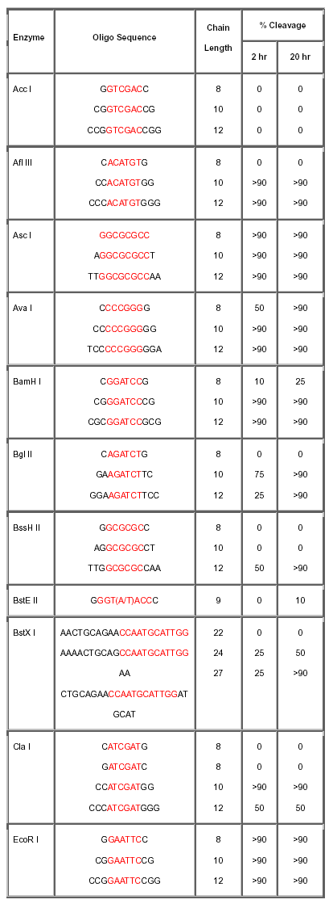
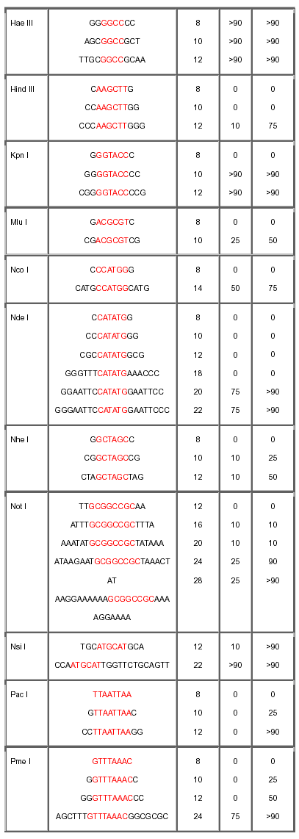

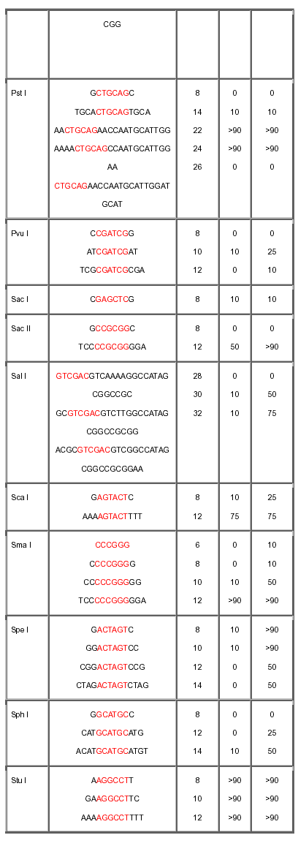
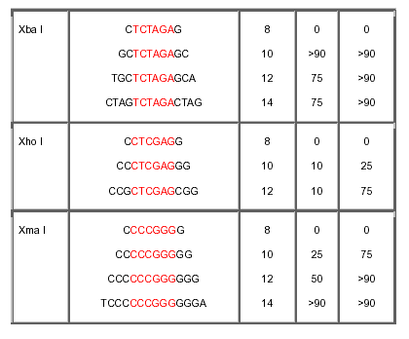

NOTE: To test the varying requirements restriction endonucleases have for the number of bases flanking their recognition sequences, a series of short, double-stranded oligonucleotides that contain the restriction endonuclease recognition sites (shown in red) were digested. This information may be helpful when choosing the order of addition of two restriction endonucleases for a double digest (a particular concern when cleaving sites close together in a polylinker), or when selecting enzymes most likely to cleave at the end of a DNA fragment. The experiment was performed as follows: 0.1 A260 unit of oligonucleotide was phosphorylated using T4 polynucleotide kinase and g-[32P] ATP. 1 µg of 5´ [32P]-labeled oligonucleotide was incubated at 20°C with 20 units of restriction endonuclease in a buffer containing 70 mM Tris-HCl (pH 7.6), 10 mM MgCl2, 5 mM DTT and NaCl or KCl depending on the salt requirement of each particular restriction endonuclease. Aliquots were taken at 2 hours and 20 hours and analyzed by 20% PAGE (7 M urea). Percent cleavage was determined by visual estimate of autoradiographs. As a control, self-ligated oligonucleotides were cleaved efficiently. Decreased cleavage efficiency for some of the longer palindromic oligonucleotides may be caused by the formation of hairpin loops.

